Till Controller Network Re-Image Process

Overview

This imaging process utilises the Store Jump Server as a central location to perform Till Controller Re-imaging from. It has been created with the idea that a member of store staff should be able to rebuild the controller with minimal instruction from a help desk operative, and get a controller back up and running within an hour. The process would obviously not be able to recover the system from a hardware error, but in cases where the cause of a problem was uncertain (hardware vs. software error), the process could be run as a first step to eliminate the possibility of a software error as quickly as possible.

Architecture

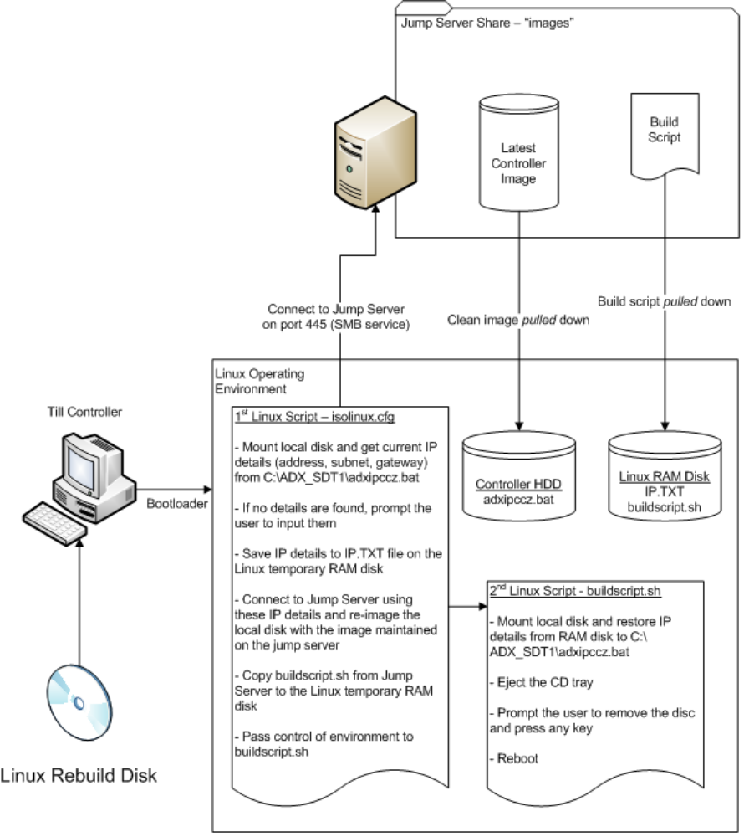

Rebuild Disc Details

The build disc is based on an open source project called PING (Part Image Is Not Ghost). The latest version of this project can be downloaded as an ISO file in its unmodified form from http://ping.windowsdream.com/. The project is based on Linux, and it is all done using shell script using the BASH terminal scripting language. This project has then been modified for our purposes by performing the following steps:

- Set up a working environment on a Linux box (Ubuntu is fine).
- Mount the ISO file and extract the contents to the working directory.
- In the tmp folder, modify the file isolinux.cfg with the relevant commands to automate the steps listed in the architecture diagram.
- In the tmp folder, modify the file logo.16 with the image to be displayed at boot time.
- Once customisation is complete, recompile the ISO file with the following command (all as a single command):

$ sudo mkisofs -D -r -cache-inodes -J -l -b isolinux.bin -no-emul-boot -boot-load-size 4 -boot-info-table -o ../storebuild.iso .

- Using a CD burning tool (ubuntu has one pre-installed), burn the ISO image to a CD.

Initial Customisations of isolinux.cfg

The isolinux.cfg file is the first configuration file that is processed by the Linux bootloader, and contains all the relevant details of the Jump Server and Controller Image, as well as the commands for obtaining the IP settings. Below is a cut and paste of the contents of the initial version of the file with the our customisations highlighted:

DEFAULT default
PROMPT 1
TIMEOUT 26
DISPLAY boot.msg
LABEL default
KERNEL kernel
APPEND vga=normal devfs=nomount pxe ramdisk_size=55000 load_ramdisk=1 init=/linuxrc prompt_ramdisk=0 initrd=initrd.gz root=/dev/ram0 rw noapic nolapic lba combined_mode=libata ide0=noprobe nomce pci=nomsi irqpoll quiet Server=10.240.8.101 Share=images User=administrator Passwd=topsecret Directory=/ After_Completion=Shell Replace_BIOS=N CIFS_Preferred=Y AUTO=Y Restore_Only=Y Image_To_Restore=current Dont_Warn_Me=N Compression_Type=gzip Its_HDA_Stupid=Y Extend_Parts_Whenever_Possible=N Verbosity=0 Unique_Message="Working... Please Wait" Cmd_1="mkdir /mnt/hdd ; mount -t msdos /dev/?da1 /mnt/hdd ; cd /mnt/hdd/adx_sdt1 ; [ -f /mnt/hdd/adx_sdt1/adxipccz.bat ] && OLDIP=$((grep lan0 adxipccz.bat | awk '{print $3}')2>&1) ; [ -f /mnt/hdd/adx_sdt1/adxipccz.bat ] && OLDROUTE=$((grep default adxipccz.bat | awk '{print $4}')2>&1) ; [ -f /mnt/hdd/adx_sdt1/adxipccz.bat ] && OLDNETMASK=$((grep lan0 adxipccz.bat | awk '{print $5}')2>&1) ; clear ; { case $OLDIP in '') echo please enter the IP Address you want to use and press enter ; read OLDIP ;; esac } ; clear ; { case $OLDROUTE in '') echo please enter the Default Gateway you want to use and press enter ; read OLDROUTE ;; esac } ; clear ; { case $OLDNETMASK in '') echo please enter the Subnet Mask you want to use and press enter ; read OLDNETMASK ;; esac } ; ifconfig eth0 $OLDIP netmask $OLDNETMASK up ; route add default gw $OLDROUTE eth0 ; touch /IP.TXT ; echo IP $OLDIP > /IP.TXT ; echo ROUTE $OLDROUTE >> /IP.TXT ; echo NETMASK $OLDNETMASK >> /IP.TXT ; cd / ; umount /mnt/hdd" Cmd_2="cp /mnt/smbfs/buildscript.sh /" Cmd_3="/buildscript.sh"
LABEL dummy
KERNEL kernel

Cmd_1 contains a string of commands separated by a “;” - these commands are responsible for obtaining the IP details, and applying them to the network adaptor (eth0), and writing them to a file on the temporary RAM disk (IP.TXT). This command is run BEFORE attempting any network activity.

Cmd_2 copies the the buildscript.sh file from the Jump Server to the temporary RAM disk. This command is run AFTER the network settings are instantiated Jump Server images folder has been mounted.

Cmd_3 calls the buildscript.sh file which then completes the build process. This command is is run AFTER the clean image has been applied to the controller.

Initial Contents of buildscript.sh

The buildscript.sh file has been created from scratch, and is intended to reside centrally on the Jump Server so that any changes to the build process can be made once, rather than having to redistribute the build CD every time something changes. Currently the script simply re-inserts the IP details into the newly built clean controller image, however, in future we would be able to script any other settings should we want to. Below is a cut n paste of the initial version of the buildscript.sh file:

#!/bin/bash
#logfile=script.log
#exec > $logfile 2>&1
mount -t msdos /dev/?da1 /mnt/hdd
cd /mnt/hdd/adx_sdt1
export OLDIP="$(grep IP /IP.TXT | awk '{print $2}')"
export OLDROUTE="$(grep ROUTE /IP.TXT | awk '{print $2}')"
export OLDNETMASK="$(grep NETMASK /IP.TXT | awk '{print $2}')"
export IMAGEIP="$(grep lan0 adxipccz.bat | awk '{print $3}')"
export IMAGEROUTE="$(grep default adxipccz.bat | awk '{print $4}')"
export IMAGENETMASK="$(grep lan0 adxipccz.bat | awk '{print $5}')"
touch adxipccz.bat
sed -i "s=$IMAGEIP=$OLDIP=;s=$IMAGEROUTE=$OLDROUTE=;s=$IMAGENETMASK=$OLDNETMASK=" adxipccz.bat
eject
clear
echo "Restore complete!"
echo "Please remove the disc from the tray then press any key to reboot."
read -p \$
cd /
umount /mnt/hdd
shutdown -r now

Customising the Boot up Graphic

In order to customise the boot up graphic, there needs to be some Linux packages installed on the Linux environment (use whichever package manager you wish):

- syslinux – this package contains the programs ppmtolss16 and lss16toppm
- gimp – this is a graphics editing package

To open the the logo.16 file in gimp, you will need to run the following command to convert the file to an editable format:

$ lss16toppm <logo.16 >logo16.ppm

Now run gimp and edit the logo16.ppm file as you wish (ensuring that you do not use more than 16 colours).

Next convert file back to its original format with the following command:

$ ppmtolss16 < logo16.ppm >logo.16

Central Server (Jump Server)

The set up of the server is very simple:

- Create a folder called 'images' and share it as 'images'.
- Set the permissions for the folder as 'everyone' 'read-only'.
- Store the latest controller image and the buildscript.sh in this folder.
- Ensure that the IP address of this server is the referenced in the isolinux.cfg file (Server=[ip address] string)

That's all!

Network Requirements

For this whole process to work, there needs to be a route enabled on the firewalls between the stores and the Jump Server. The port required to be open is 445 TCP.

PCI / Security Statement

There is no inherent risk of this rebuild process creating any additional attack vector to our card-holder environment, as the image that is stored on the Jump Server is clean of card data, and the permissions of the shared folder are locked down in such a way that only a single user has only read-only access to it, and that user has no further access to any other folders or systems. The additional port (445) that we are opening will be for the till controller to pull data from the Jump Server, and so for it to be of any use to an intruder, they would have to already be on a till controller.

